Containerized Insurance App Deployment on Kubernetes Report

  - Course Name: Data Analytics

Institution Name: Medicaps University – Datagami Skill Based Course

Sr no | Student Name | Enrolment Number
1. | Yash Shivastava | EN22CS3011111
2. | Vishwas Bhargav | EN22CS3011095
3. | Yashi Harne | EN22CS3011116
4. | Dixika Verma | EN22ME304027
5. | Anvesha Wankhade | EN22ME304014
Student Name(s) & Enrolment Number(s):

Group Name : Group 07D10
Project Number : DO-20
Industry Mentor Name:
University Mentor Name : Prof. Avnesh Joshi
Academic Year: 2025-2026

Problem Statement & Objectives -

Problem Statement:

In today’s digital era, insurance applications must provide uninterrupted service, fast performance, and seamless updates to users. Customers expect to access policies, submit claims, and track approvals at any time without experiencing downtime or service disruption.
However, traditional deployment approaches face several challenges:
- Application downtime during new releases or updates
- Manual deployment processes leading to configuration errors
- Difficulty in scaling the application during high traffic
- Lack of version control and rollback mechanisms
- Poor environment consistency between development and production
To overcome these challenges, there is a need for a modern, automated, and scalable deployment solution. This project focuses on deploying a containerized Insurance MERN Stack application (MongoDB, Express.js, React.js, Node.js) onto a Kubernetes cluster using Minikube. The system will use Docker for containerization and Kubernetes for orchestration of application components such as frontend, backend, and database services.
A major requirement of this deployment is the implementation of zero-downtime rolling updates. This ensures that when a new version of the application is released,
Kubernetes gradually replaces old pods with new ones without interrupting active user sessions or affecting service availability. If any failure occurs during deployment, the system should support automatic rollback to the previous stable version.
Additionally, the project integrates CI/CD practices using Git and Jenkins or GitHub Actions to automate the process of:
- Building application code
- Creating Docker images
- Pushing images to a container registry
- Deploying updates to the Kubernetes cluster
The goal is to design a deployment architecture that ensures high availability, scalability, reliability, and automation while following modern DevOps best practices.
Ultimately, this project addresses the problem of managing application deployment efficiently and reliably, ensuring continuous service delivery and improved operational efficiency for an insurance-based web application.

2.Project Objectives:

The primary objective of this project is to design and implement a scalable, automated, and highly available deployment architecture for an Insurance MERN Stack application using Kubernetes and modern DevOps practices.
The detailed objectives are as follows:
- Containerization of Application Components
- To package the frontend (React), backend (Node.js/Express), and database (MongoDB) into Docker containers.
- To ensure environment consistency across development, testing, and deployment stages.
- To maintain image versioning for controlled releases.

- Kubernetes-Based Orchestration
- To deploy the containerized application on a Kubernetes cluster (Minikube).
- To create and configure Kubernetes manifests including:
- Deployments
- Services
- ConfigMaps
- Secrets
- To manage pod lifecycle, networking, and inter-service communication effectively.

- Implementation of Zero-Downtime Rolling Updates
- To configure Kubernetes rolling update strategy.
- To ensure uninterrupted service availability during application upgrades.
- To enable automatic rollback in case of deployment failure.
- To maintain continuous user access during version transitions.

- Scalability and High Availability
- To configure multiple replicas of application pods.
- To enable horizontal scaling when demand increases.
- To ensure load balancing across pods for better performance and reliability.

- Adoption of DevOps Best Practices
- To implement Infrastructure as Code (YAML manifests).
- To maintain modular and maintainable deployment configuration.
- To improve operational efficiency and system reliability.

- Implementation of CI/CD Pipeline

- To design and implement a Continuous Integration and Continuous Deployment (CI/CD) pipeline using tools such as Jenkins / GitHub Actions.
- To automate the process of code build, testing, Docker image creation, and image push to Docker Hub.
- To integrate the CI/CD pipeline with Kubernetes for automated deployment.
- To ensure faster, reliable, and error-free application releases.
- To maintain version control and enable automated rollback in case of deployment failures.

3.Scope of the Project:

- Application Containerization
- Containerize the existing Insurance application using Docker.
- Build and manage Docker images.
- Push the images to a container registry such as Docker Hub.
- Kubernetes Cluster Setup
- Set up and configure a Kubernetes cluster using Minikube.
- Verify cluster functionality and connectivity using kubectl.
- Deployment Configuration
- Create Kubernetes Deployment manifests to manage application pods.
- Configure replica sets to ensure high availability and fault tolerance.
- Define resource limits and container specifications.
4) Service Exposure
- Create Kubernetes Service manifests to expose the application within or outside the cluster.
- Use NodePort or ClusterIP for application accessibility.
5) Rolling Updates Implementation
- Configure the Deployment strategy to use Rolling Updates.
- Ensure zero-downtime deployment during version upgrades.
- Validate rollout status and application continuity.

Proposed Solution -
1.Key features:
- Dockerized Insurance Application
- Kubernetes-based deployment
- High availabilty using multiple replicas
- Zero-downtime rolling updates
- Service exposure using Kubernetes Service
- Manual pod scaling support
- Basic monitoring and log verification
- Automated CI/CD pipeline for build, test, and Kubernetes deployment
2.Overall Architecture / Workflow:
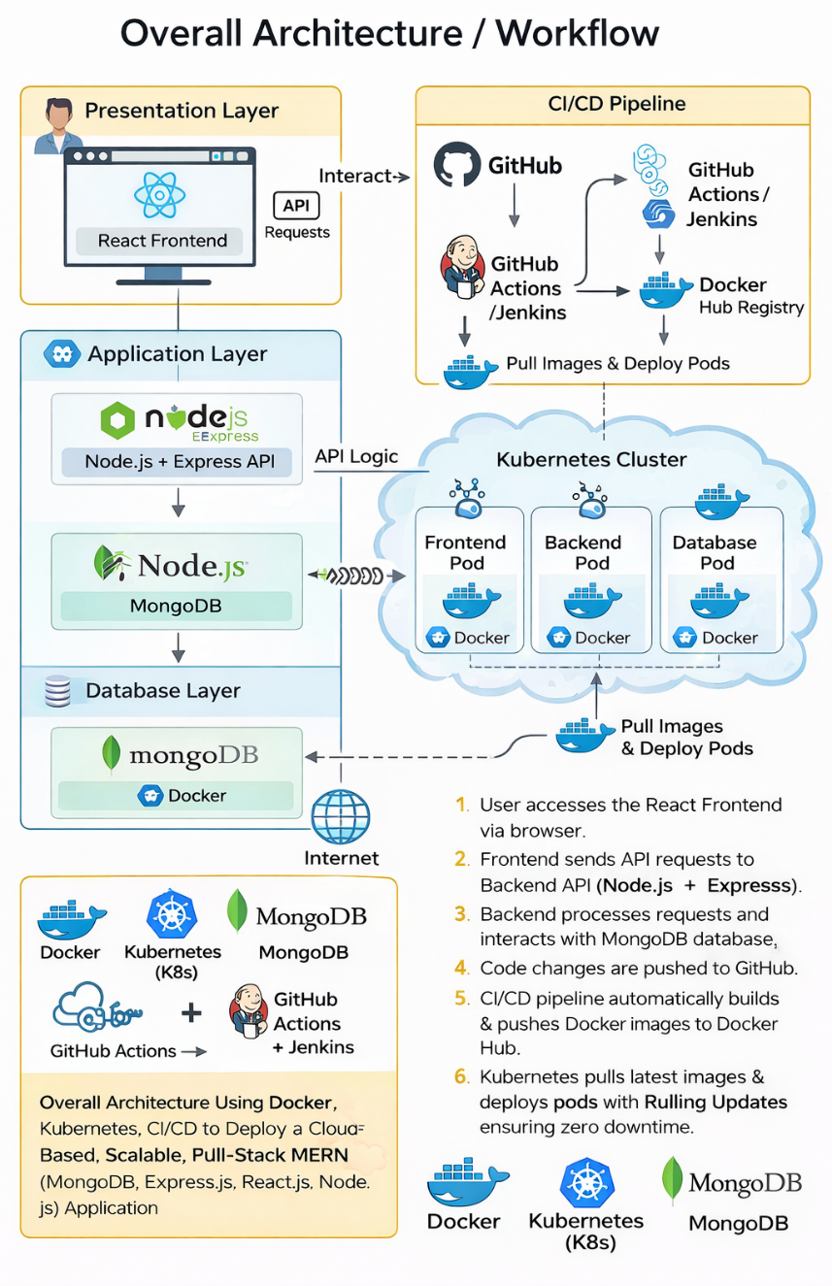

- Use Case
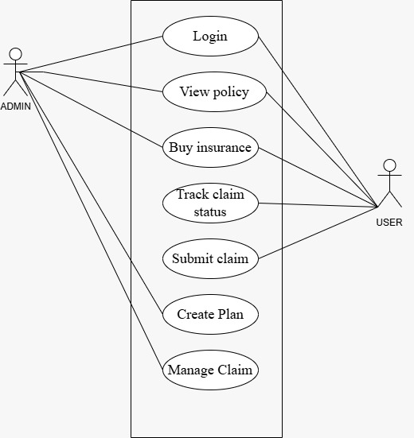
- Activity Diagram:
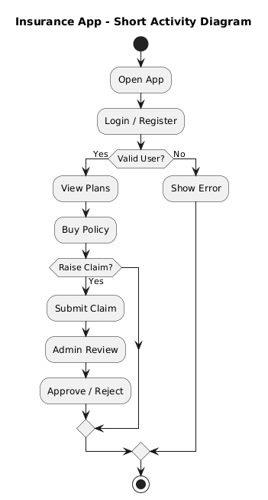

- DFD(Zero Level):
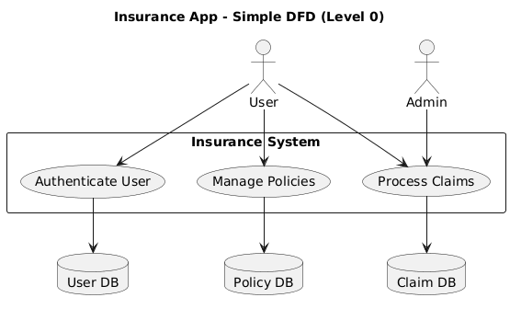

- DFD(One Level):
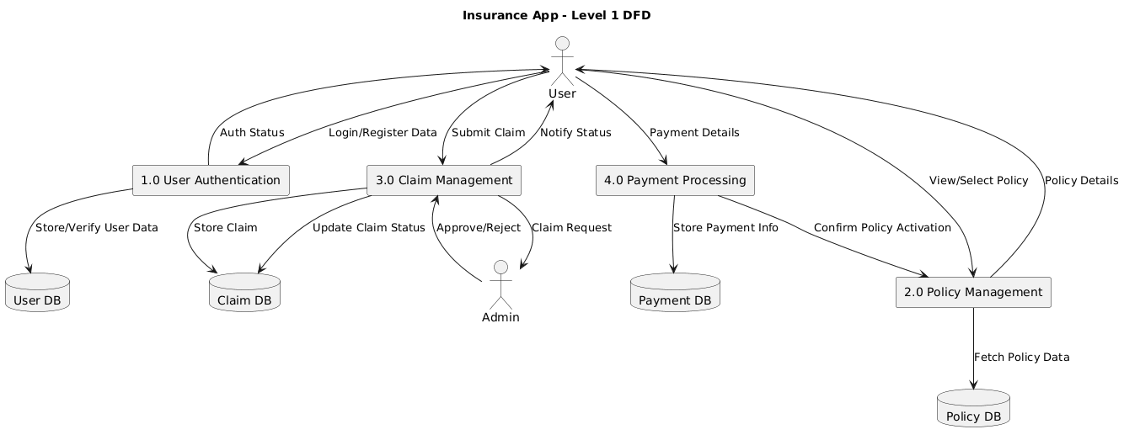

- Sequence Diagram
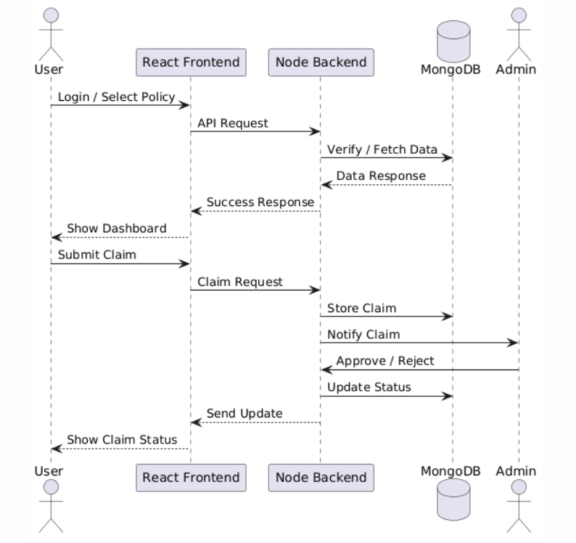
3.Tools & Technologies Used :
🔹 Git
- Version Control – Tracks code changes
- Repository – Stores project code
- Commit – Snapshot of changes
🔹 Docker
- Containerization – Packages app with dependencies
- Dockerfile – Instructions to build image
- Image – Application blueprint
- Container – Running instance of image
- Registry – Stores images (Docker Hub)
🔹 CI/CD Pipeline
- Continuous Integration (CI) – Automatically builds & tests code on every push

- Continuous Deployment (CD) – Automatically deploys application after successful build
- GitHub Actions – Automates build, test & deployment workflows
- Docker Hub – Stores Docker images
- Kubernetes – Deploys application with rolling updates
- Pipeline Workflow – Code → Build → Test → Docker Image → Push → Deploy
🔹 Kubernetes (K8s)
- Container Orchestration – Manages containers
- Cluster – Group of nodes
- Node – Machine running pods
- Pod – Smallest deployable unit
- Deployment – Manages replicas & updates
- ReplicaSet – Maintains pod count
- Service – Exposes application
- NodePort – External access in Minikube
- Namespace – Logical separation
- Secret – Sensitive data storage
🔹 MERN Stack
- MongoDB – Database
- Express.js – Backend framework
- React.js – Frontend
- Node.js – Runtime environment

Results & Output -
• Successfully deployed a containerized MERN Insurance Application on a Kubernetes cluster.
• Implemented CI/CD automation using Git, Docker, GitHub Actions.
• Achieved zero-downtime deployment using Kubernetes Rolling Updates.

• Ensured application scalability, high availability, and fault tolerance.
• Integrated cloud infrastructure (AWS) for production-ready deployment.

1.Screenshots/Outputs
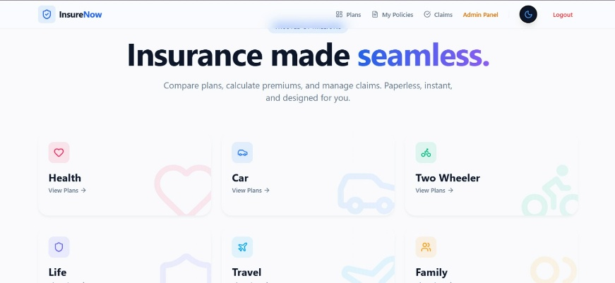
Fig1.1 Landing Page / Home Page
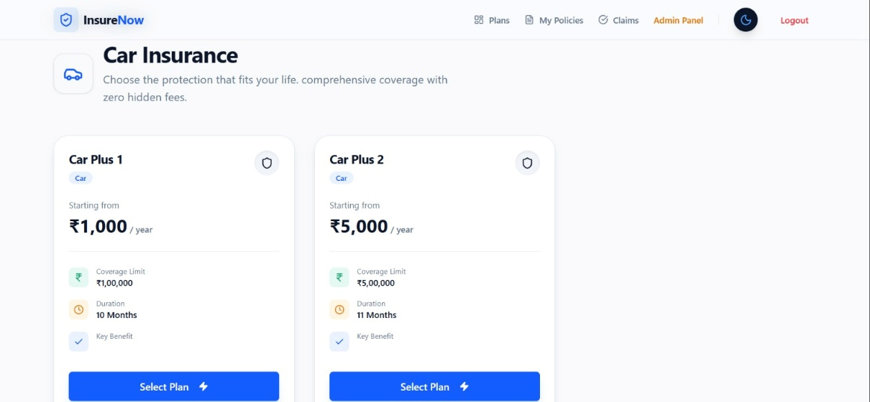
Fig1.2 Plans
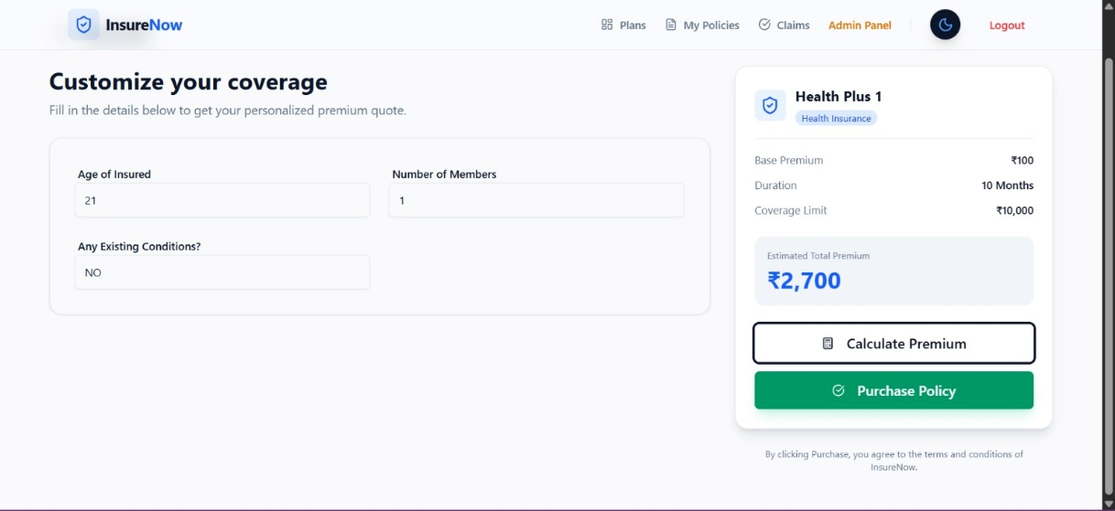
Fig1.3 Buy Policy
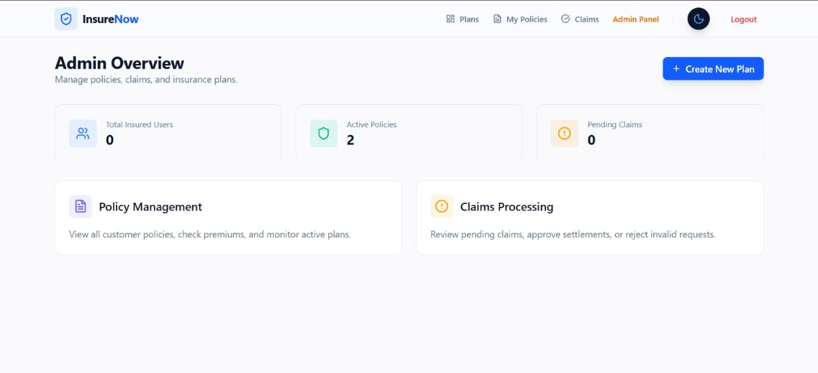
Fig1.3 Admin Panel

2.Reports/Dashboards/Model
📊 Reports
- Kubernetes pod & replica status
- Application logs & health checks
- CI/CD build history and deployment logs
📈 Dashboards
- Jenkins / GitHub Actions pipeline dashboard
- Kubernetes cluster monitoring
- CPU, memory & pod health metrics
- Automated build, test, and deployment status tracking

🏗 Models
- Kubernetes deployment architecture
- Rolling update model (zero downtime)
- CI/CD pipeline workflow model (Code → Build → Test → Docker → Deploy to Kubernetes)
3.Key Outcomes
1. Zero Downtime Deployment
- Implemented Rolling Update strategy
- No service interruption during updates
2. Scalability
- Horizontal scaling using replicas
- Load distributed across multiple pods
3. High Availability
- Self-healing pods (auto-restart)
- ReplicaSets ensure required pod count
4. Production-Ready Architecture
- Secure configuration management
- Containerized microservice-based structure
- Cloud-compatible deployment (AWS)
5. Improved DevOps Workflow
- Version-controlled infrastructure (YAML manifests)
- Continuous integration & delivery
- Efficient collaboration between Dev and Ops
Conclusion -
The deployment of the Insurance MERN Stack application on Kubernetes successfully demonstrates the implementation of modern containerized and cloud-native architecture. By using Docker for containerization and Kubernetes for orchestration, the application is deployed in a scalable, reliable, and efficient environment. Containerization ensures consistency across different environments, eliminating dependency-related issues and improving deployment stability.
One of the key achievements of this project is the implementation of zero-downtime deployment using Kubernetes Rolling Updates. This strategy allows new versions of the

application to be deployed gradually without interrupting user access. Health checks such as readiness and liveness probes ensure that only stable and fully functional pods receive traffic. This guarantees high availability, which is critical for an insurance application where uninterrupted service is essential.

Kubernetes enhances the system with features like auto-scaling, self-healing, and load distribution. ReplicaSets maintain the required number of running pods, and if any pod fails, it is automatically restarted. The architecture supports horizontal scaling, allowing the system to handle increased user traffic efficiently. Services and load balancing mechanisms ensure smooth communication between frontend, backend, and database components.

The project also integrates a CI/CD pipeline using Jenkins / GitHub Actions to automate code integration, testing, Docker image creation, and Kubernetes deployment. This automation minimizes manual intervention, reduces deployment errors, and enables faster and more reliable application releases. Continuous Integration ensures that every code change is tested and validated, while Continuous Deployment enables seamless delivery of updates to the Kubernetes cluster.

The project also demonstrates cloud readiness by supporting deployment on platforms like AWS. The infrastructure design allows easy transition from a local Kubernetes setup to a production cloud environment. Secure configuration management using Kubernetes Secrets and controlled network access further strengthens the reliability and security of the application.

Overall, this project delivers a scalable, highly available, automated, and production-ready deployment of a MERN-based Insurance application. It showcases strong understanding of containerization, Kubernetes orchestration, CI/CD automation, rolling updates, and modern DevOps practices, ensuring a robust and efficient system architecture. Conclusion –

Future Scope & Enhancements –
- Cloud-Native Production Deployment
  - Move from Minikube to a fully managed Kubernetes service like AWS EKS or GCP GKE for production-grade deployment.
- Advanced Monitoring and Analytics
  - Integrate tools like Prometheus, Grafana, or ELK Stack to monitor performance, resource usage, and generate real-time dashboards.
- Auto-Scaling and Load Optimization

  - Implement Horizontal Pod Autoscaling (HPA) to dynamically scale the application based on traffic or CPU/memory usage.
- Improved Security
  - Add enhanced security features like network policies, RBAC, encryption at rest and in transit, and secure API gateways.
- Microservices Architecture
  - Break the monolithic backend into microservices to improve maintainability, scalability, and independent deployment of modules.
- High Availability and Disaster Recovery
  - Implement multi-zone Kubernetes clusters, automated backups, and disaster recovery strategies for critical insurance data.
- CI/CD Enhancements
  - Add automated testing, canary deployments, and advanced rollback strategies to further improve reliability.
- Integration with External Services
  - Integrate payment gateways, notification services (email/SMS), or AI-driven insurance claim processing for enhanced functionality.

